***Ideation Phase***

***Problem Statements***

|  |  |
| --- | --- |
| Date | 17 October 2022 |
| Team ID | PNT2022TMID26022 |
| Project Name | Smart Solutions for Railways |
| Maximum Marks | 2 Marks |

**Customer Problem Statement:**

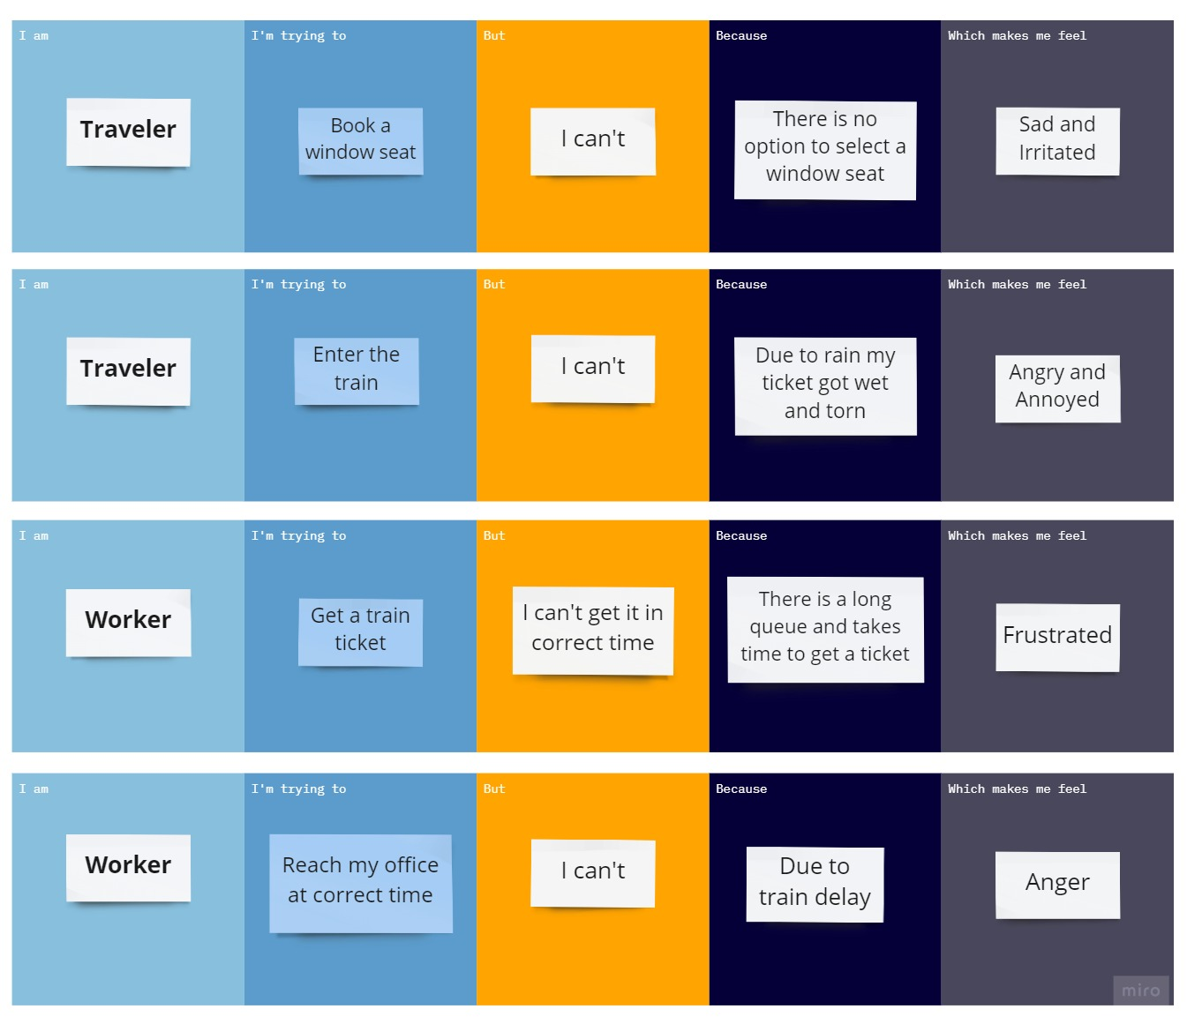

|  |  |  |  |  |  |
| --- | --- | --- | --- | --- | --- |
| ***Problem Statement (PS)*** | ***I am a*** | ***I’m trying to*** | ***But*** | ***Because*** | ***Which makes me feel*** |
| PS-1 | Traveler | Book a Window Seat | I Can’t | There is no Option to Select Window seat | Sad and Irritated |
| PS-2 | Traveler | Enter the Train | I Can’t | Due to Rain My Train Ticket got Wet and Tore | Annoyed and Angry |
| PS-3 | Worker | Get a Train Ticket | I Can’t get it in Correct Time | There is long Queue and Takes Time to get a Ticket | Frustrated |
| PS-4 | Worker | Reach my office at Correct Time | I Can’t | Due to Train Delay | Anger |